Waveform Analysis Using Testbenches 2
1. Title 2
2. Objective 2
3. Theory (Multi-Level) 2
3.1 Beginner — Simple Intuition 2
3.2 Intermediate — Engineering View 2
3.3 Advanced — Signal/Architecture Level 3
4. Architecture / Concept 5
GTKWave Analysis Layers 5
Waveform Navigation Workflow 6
5. Implementation 6
Testbench Files for This Module 6
Pre-saved GTKWave Layout 7
6. Lab / Hands-on Section 7
Lab A: Full SoC Waveform Analysis 7
Lab B: AXI Handshake Analysis 8
Lab C: Protocol Debug Scenario 8
7. Waveform / Verification Insight 8
Checklist: What to Verify in tb_top.fst 8
Timing Reference Table 9
8. Common Issues & Debug Tips 9
GTKWave Tips 10
Debug Technique: Binary Search in Waveform 10
9. Summary 10
Interview Question Topics from Waveform Analysis 11

Waveform Analysis Using Testbenches
Course: PicoRV32 SoC with AXI-Lite & UART Integration
Lab Commands: make soc → make wave / make debug_soc

1. Title
Waveform Analysis Using Testbenches — Debugging RTL and Verifying Protocol Compliance

2. Objective
By the end of this module, learners will be able to:
- Use GTKWave to navigate large simulation waveforms (VCD/FST format)
- Identify AXI-Lite valid/ready handshake patterns in waveforms
- Verify UART 8N1 frame format by measuring bit-period timing
- Correlate simulation log output with waveform events
- Use structured waveform analysis to debug protocol violations and timing issues
- Organize GTKWave signal groups for efficient multi-layer SoC inspection

3. Theory (Multi-Level)

3.1 Beginner — Simple Intuition
A waveform viewer is like a slow-motion camera for your digital circuit. Every wire in your design is recorded over time, so you can go back and ask:
- “At exactly this moment, what was the CPU doing?”
- “Did the UART transmit ‘H’ before or after the AXI handshake?”
- “Why did the bridge get stuck in state 3?”
GTKWave reads .vcd (Value Change Dump) or .fst (Fast Signal Trace) files produced by Verilator or Icarus Verilog simulations. These files record every signal transition in the simulation.

3.2 Intermediate — Engineering View
VCD vs FST: | Format | File size | Load speed | Tool | |——–|———–|———–|——| | .vcd | Large (147 MB for tb_top.vcd) | Slow | Any viewer | | .fst | Compressed (~5 MB) | Fast | GTKWave |
Always convert before viewing:
vcd2fst tb_top.vcd tb_top.fst # ~10-20× smaller
gtkwave tb_top.fst &
Available waveform files in this project:
File | Source | Contains
tb_top.vcd / tb_top.fst | make soc | Full SoC simulation (primary)
tb_top_debug.vcd / tb_top_debug.fst | make debug_soc | Debug TB with extra logging
tb_axi_lite.vcd | make axi_uart | AXI-UART module test
tb_axi_lite_standalone.vcd | make axi_sa | AXI handshake demo
tb_riscv_axi_lite.vcd | make riscv_axi | CPU-AXI integration demo
tb_uart.vcd | make uart | UART loopback test
tb_picorv32.vcd | make pico | PicoRV32 standalone
tb_mem_soc.vcd | make soc_pico_uart_mem | Direct-bus MMI SoC

3.3 Advanced — Signal/Architecture Level
Testbench structure in tb/tb_top.v:
Three concurrent processes run simultaneously in the testbench: 1. Clock generator: always #10 clk = ~clk (50 MHz) 2. UART TX monitor (initial begin : uart_monitor): Decodes serial bitstream into bytes using bit-time sampling (BAUD_HALF, BAUD_FULL delays) 3. Byte logger (initial begin : byte_logger): Prints [TB] RX byte: X for every FIFO entry — runs independently to avoid race conditions 4. Test sequencer (initial begin : test_seq): Waits for 10 greetings, sends PING, verifies echo
UART Monitor timing constants:
localparam CLK_PERIOD = 20; // 20 ns → 50 MHz
localparam UART_BIT_CYCLES = 434; // cycles per bit @115200, 50MHz
localparam BAUD_HALF = 1_000_000_000 / 115200 / 2; // 4340 ns
localparam BAUD_FULL = 1_000_000_000 / 115200; // 8680 ns
UART monitor algorithm:
forever begin
@(negedge uart_tx_pin); // 1. Wait for start-bit falling edge
#(BAUD_HALF); // 2. Jump to mid-start-bit
if (uart_tx_pin == 1'b0) begin // 3. Confirm genuine start bit (not glitch)
for (bit_i = 0; bit_i < 8; bit_i++) begin
#(BAUD_FULL); // 4. Jump to mid-bit of each data bit
mon_byte[bit_i] = uart_tx_pin;
end
#(BAUD_FULL); // 5. Skip stop bit
rx_fifo[rx_wr_ptr & 63] = mon_byte;
rx_wr_ptr++;
end
end

4. Architecture / Concept

GTKWave Analysis Layers
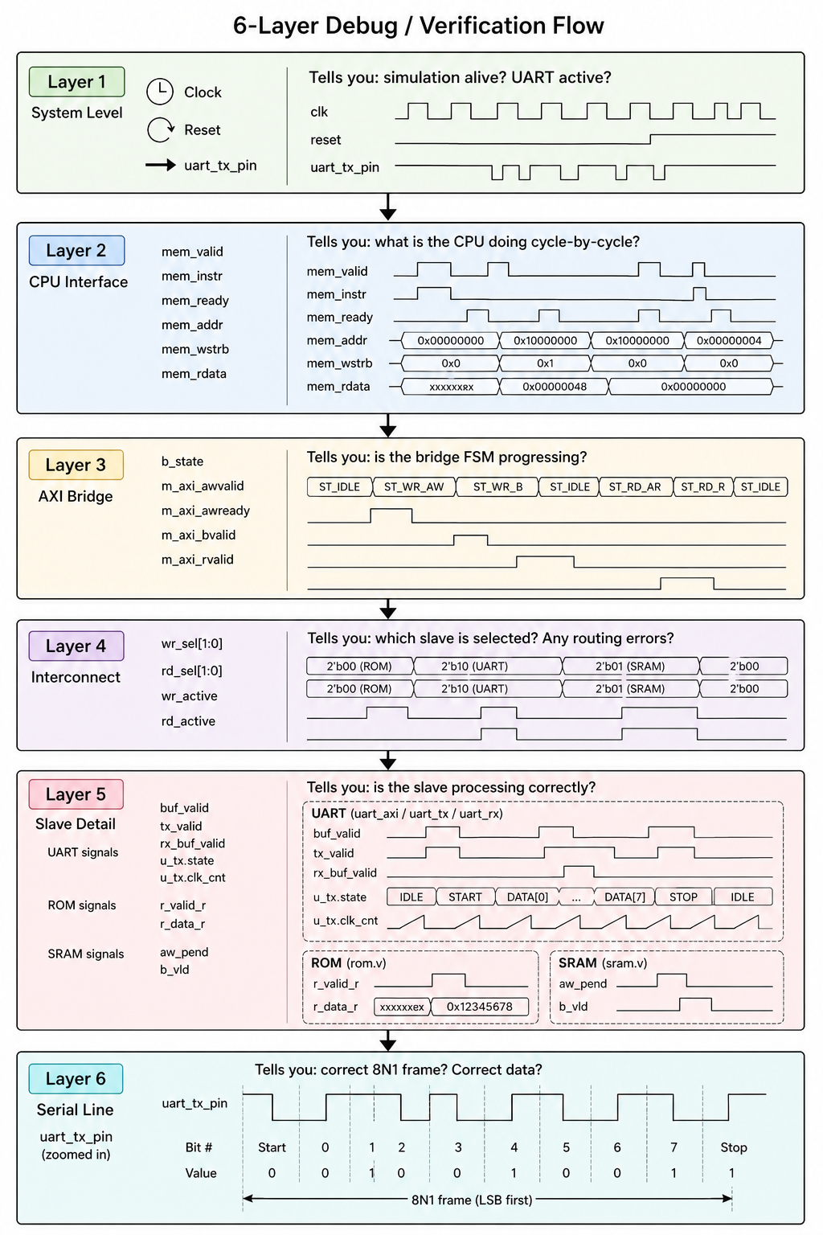

Waveform Navigation Workflow
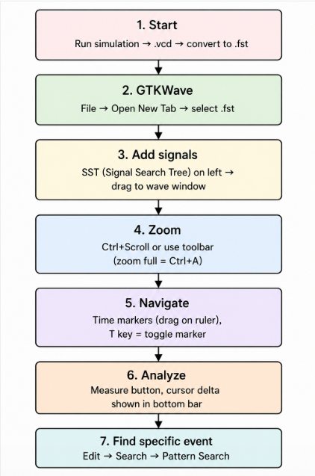

5. Implementation

Testbench Files for This Module
File | Key Features
tb/tb_top.v | UART bit decoder, 64-byte FIFO, byte logger, PING test
tb/tb_debug.v | Additional debug signal display; structured test log format
tb/tb_axi_lite_standalone.v | Clean AXI handshake demo with $display labels
tb/tb_riscv_axi_lite.v | Step-by-step AXI trace with human-readable messages
uart.gtkw | Pre-saved GTKWave configuration for UART signals

Pre-saved GTKWave Layout
gtkwave tb_uart.vcd -a uart.gtkw &
This opens GTKWave with pre-configured signal groups for UART analysis.

6. Lab / Hands-on Section

Lab A: Full SoC Waveform Analysis
Step 1: Generate the waveform
cd /home/deep/nielit/projects/tested_projects/picorv32_soc
make soc
Step 2: Convert and open
vcd2fst tb_top.vcd tb_top.fst
gtkwave tb_top.fst &
Or simply:
make wave # Does vcd2fst + gtkwave automatically
Step 3: Add signal groups
In GTKWave’s SST (left panel), expand the hierarchy:
tb_top
└── u_dut (top module)
├── (signals in top.v: b_state, m_axi_*)
├── u_cpu (picorv32)
│ └── mem_valid, mem_addr, mem_rdata, ...
├── u_interconnect
│ └── wr_sel, rd_sel, wr_active, ...
├── u_rom
│ └── r_valid_r, r_data_r
├── u_sram
│ └── aw_pend, b_vld
└── u_uart
├── buf_valid, aw_got, w_got
├── u_tx (uart_tx)
│ └── state, clk_cnt, bit_cnt, shift_reg, tx
└── u_rx (uart_rx)
└── state, rx_buf_valid, data_out
Step 4: Zoom to first UART write
Use Edit → Search → Timestamp or CTrl+G to jump to time ≈ 5 µs (first UART TX byte).
Step 5: Decode the first byte manually
In GTKWave, zoom into uart_tx_pin signal: - Find the falling edge (start bit) - Count 8 data bits, each lasting ≈ 434 × 20 ns = 8680 ns - Sample mid-bit: start + 4340 ns, + 8680 ns × n - Build byte from LSB to MSB - Verify it equals 0x48 (‘H’)

Lab B: AXI Handshake Analysis
make axi_sa
gtkwave tb_axi_lite_standalone.vcd &
Exercises:
- Measure AW handshake latency:
  - Place Marker 1 at the cycle where awvalid rises
  - Place Marker 2 at the cycle where awready rises
  - Delta = handshake latency (should be 1 cycle in this testbench)
- Find Write Response:
  - After W handshake: how many cycles until bvalid=1?
  - Expected: 1 cycle (slave asserts bvalid immediately)
- Verify wstrb:
  - What is wstrb during the write? (Should be 0xF = 4'b1111)
- Confirm data integrity:
  - What is wdata at the W handshake? (0xA5A5A5A5)
  - What is rdata at the R handshake? (Should match)

Lab C: Protocol Debug Scenario
make riscv_axi
gtkwave tb_riscv_axi_lite.vcd &
Compare the terminal output with the waveform: - Find “Step 1: Send Address” → locate m_awvalid=1 in waveform - Find “AWREADY = 1” → find the exact cycle s_awready rises - Find “BVALID = 1” → locate s_bvalid transition
This exercise teaches correlation between $display output (timing logs) and actual waveform transitions.

7. Waveform / Verification Insight

Checklist: What to Verify in tb_top.fst
System initialization: - [ ] reset=1 for first 10 cycles - [ ] After reset=0: b_state=0 (ST_IDLE), m_axi_awvalid=0 - [ ] First mem_addr=0x0000_0000 (instruction fetch)
Instruction fetch verification: - [ ] mem_instr=1 on all instruction fetches - [ ] rd_sel=3'b001 (ROM selected) for first 50+ accesses - [ ] mem_rdata matches entries in rtl/rom.hex
AXI write to UART: - [ ] m_axi_awaddr=0x1000_0000 when CPU writes to UART_TX - [ ] wr_sel=3'b100 (UART selected) at that moment - [ ] s2_awvalid=1 (only UART’s AW channel asserted, not S0/S1) - [ ] u_uart.aw_got=1 then w_got=1 → buf_valid=1 → u_tx.valid=1
UART TX frame: - [ ] uart_tx_pin falls to 0 (start bit) - [ ] 8 data bits, each lasting 434 cycles (8680 ns) - [ ] Returns to 1 (stop bit), then stays 1 (idle) - [ ] Total frame = 4340 cycles = 86.8 µs
PING echo test: - [ ] uart_rx_pin driven by testbench (falls to 0 for ‘P’, ‘I’, ‘N’, ‘G’) - [ ] u_uart.u_rx.data_valid pulses for each received byte - [ ] CPU reads status 0x1000_0008 until rx_buf_valid=1 - [ ] CPU reads 0x1000_0004 → gets received byte - [ ] CPU writes received byte back to 0x1000_0000 → echo

Timing Reference Table
Event | Simulated Time
Reset released | ~200 ns
First instruction fetch | ~220 ns
First UART byte ‘H’ starts | ~3–5 µs
First greeting ‘H’ fully serialized | ~90 µs
All 10 greetings complete | ~23 ms
PING bytes sent by TB | ~23 ms
TEST PASSED | ~23.4 ms

8. Common Issues & Debug Tips
Issue in Waveform | Meaning | Fix
b_state stuck at non-zero | AXI bridge deadlock | Check which slave’s handshake is missing valid or ready
wr_sel=3'b000 | Address decoder default triggered | CPU accessed an unmapped address; check mem_addr
uart_tx_pin always 1 | No data transmitted | Check buf_valid and aw_got/w_got in u_uart
Short glitch on uart_tx_pin | Not a start bit (< BAUD_HALF) | Monitor validates: it re-checks mid-bit, ignores glitches
m_axi_rdata always 0x13 | ROM returning NOP | ROM not loaded correctly — check [ROM] loaded from... log
No bvalid pulse | Slave never responds | Expand slave signals — check if slave received awvalid+wvalid
mem_instr=0 for many cycles | CPU in memory access | Normal: load/store operations; check address
Simulation ends unexpectedly | Timeout watchdog fired | Check [TB] ERROR: Simulation TIMEOUT in log

GTKWave Tips
Ctrl+A → Zoom to fit all signals
Ctrl+Scroll → Zoom in/out at cursor
T → Place/cycle through time markers
Ctrl+G → Go to specific time
Shift+Click → Extend selection
Color groups → Right-click signal → Highlight → Color (improves readability)
Signal search → Edit → Search → Signal Search Tree

Debug Technique: Binary Search in Waveform
Symptom: "TEST FAILED" output
1. Jump to conclusion time → check echo[0..3] vs expected PING
2. If echo = 0x00: CPU never echoed → trace uart_putc calls
3. If echo[0] wrong: trace UART RX path, check rx_buf_data
4. If CPU never called uart_getc: trace uart_getc status poll
5. Trace backwards to first wrong event → root cause

9. Summary
Skill | Tool / Technique
VCD compression | vcd2fst tb_top.vcd tb_top.fst → 30× size reduction
Signal navigation | SST hierarchy in GTKWave → expand instances
AXI verification | Look for simultaneous VALID+READY in both channels
UART decoding | Measure 434-cycle bit periods; build byte LSB-first
Bridge debug | Monitor b_state[2:0] for FSM stuck conditions
Address routing | Monitor wr_sel/rd_sel one-hot signals in interconnect
Latency measurement | GTKWave time markers (T key) for cycle-accurate measurement
Waveform files | 8 different VCD files covering each test scenario

Interview Question Topics from Waveform Analysis
- “How do you verify an AXI handshake?” → Both VALID and READY must be 1 at the same rising edge
- “How do you debug a UART framing error?” → Measure bit period in GTKWave; verify mid-bit sampling alignment
- “How do you find a stalled AXI transaction?” → VALID=1 but READY never responds → check slave state machine
- “What is the latency from CPU write to UART bit?” → Bridge latency (3 cycles) + UART start-bit (434 cycles) = ~437 cycles = 8.74 µs at 50 MHz
- “How do you check the address decoder is correct?” → Monitor wr_sel/rd_sel one-hot and verify it changes correctly with mem_addr

Previous: Sub-Module 8 — Full SoC Integration
Back to: Master Index
This module serves as the verification reference for the entire course. Keep these waveform files (tb_top.fst, tb_top_debug.fst, tb_axi_lite_standalone.vcd, tb_riscv_axi_lite.vcd) as your debugging toolkit.

